Lab 5

Joud ALjehani -2111644

1. 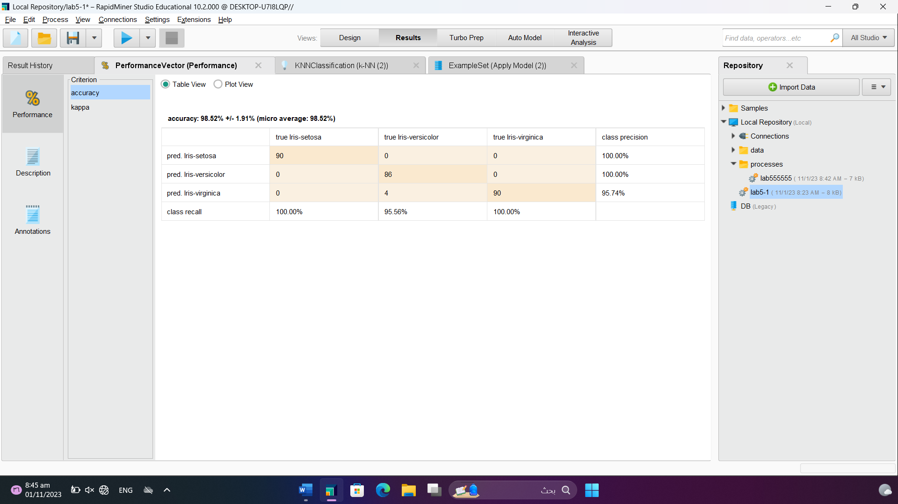Report the percentage of the kNN validation model you use above. Specify the parameter you have chosen.

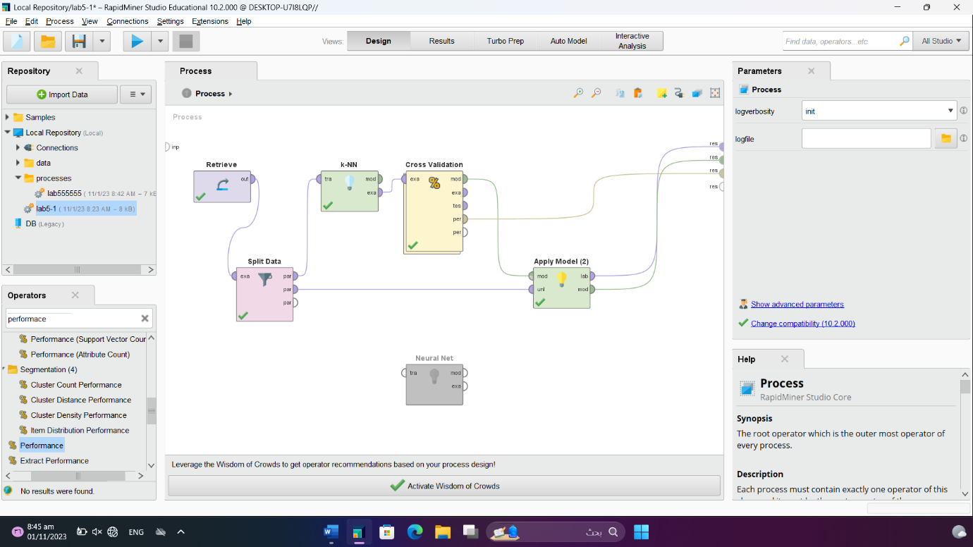

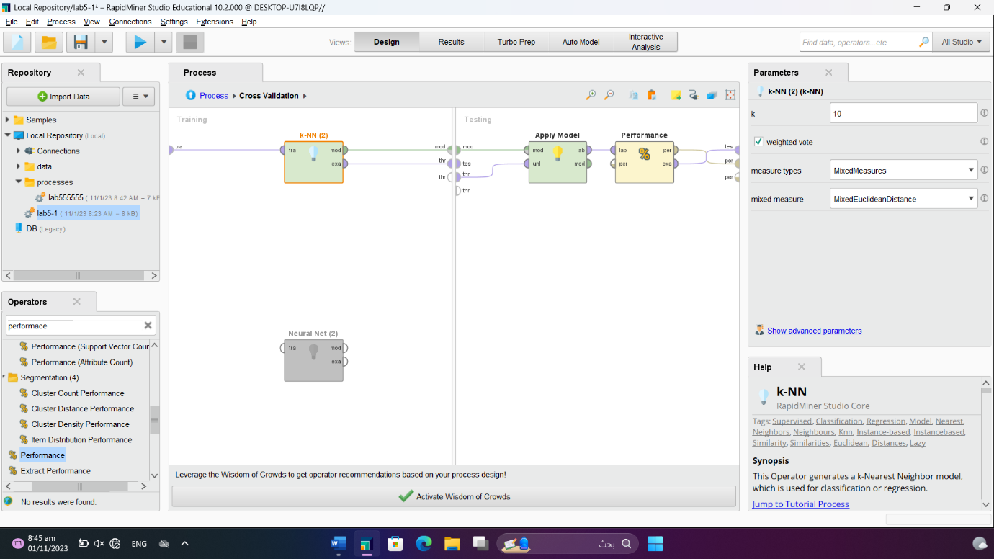

1. Run NeuralNet operator with Iris dataset and do the following: • Report the percentage of the validation model you decided to use. Specify the parameter you have chosen.

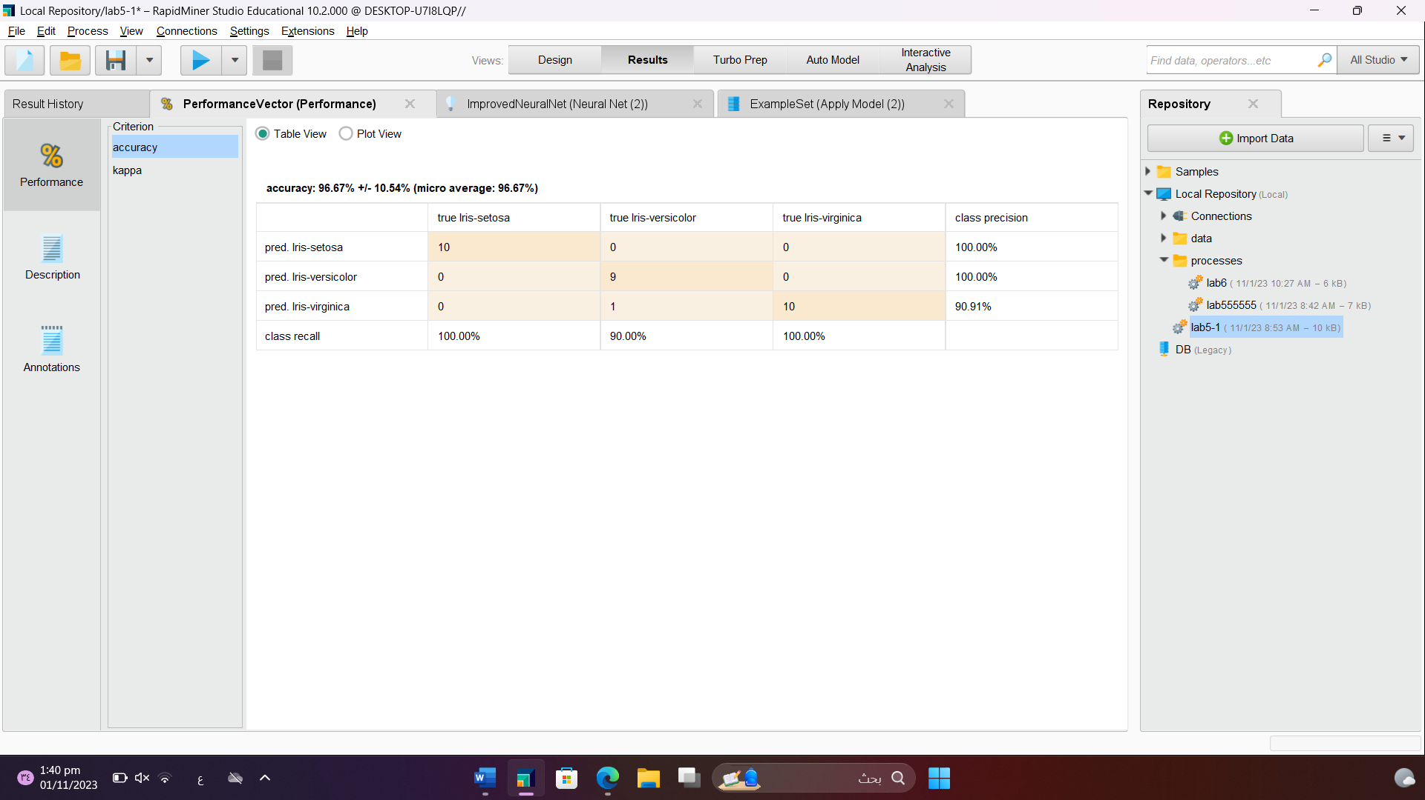

• Show your validation model (capture the image)

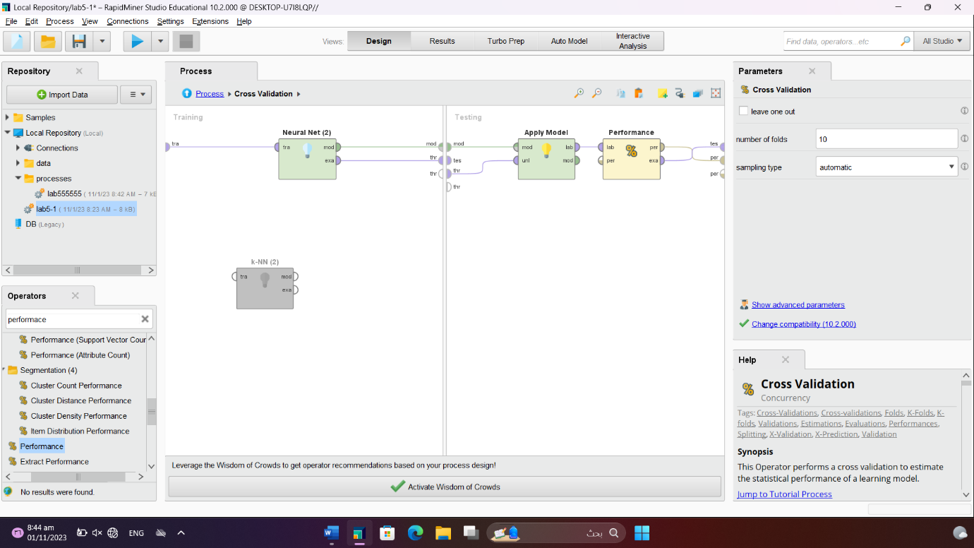

• Show your final model (capture the image)

• Show your final classification graph.

) Run DecisionTree operator with Iris dataset and do the following: • Report the percentage of the validation model you decided to use. Specify the parameter you have chosen

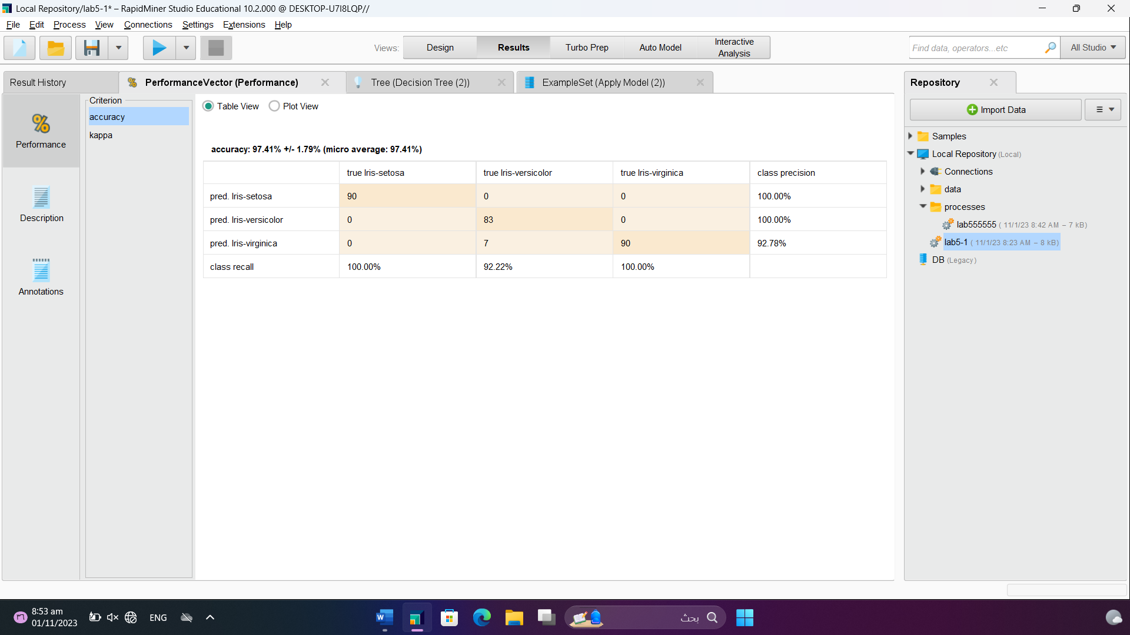

• Show your validation model (capture the image)

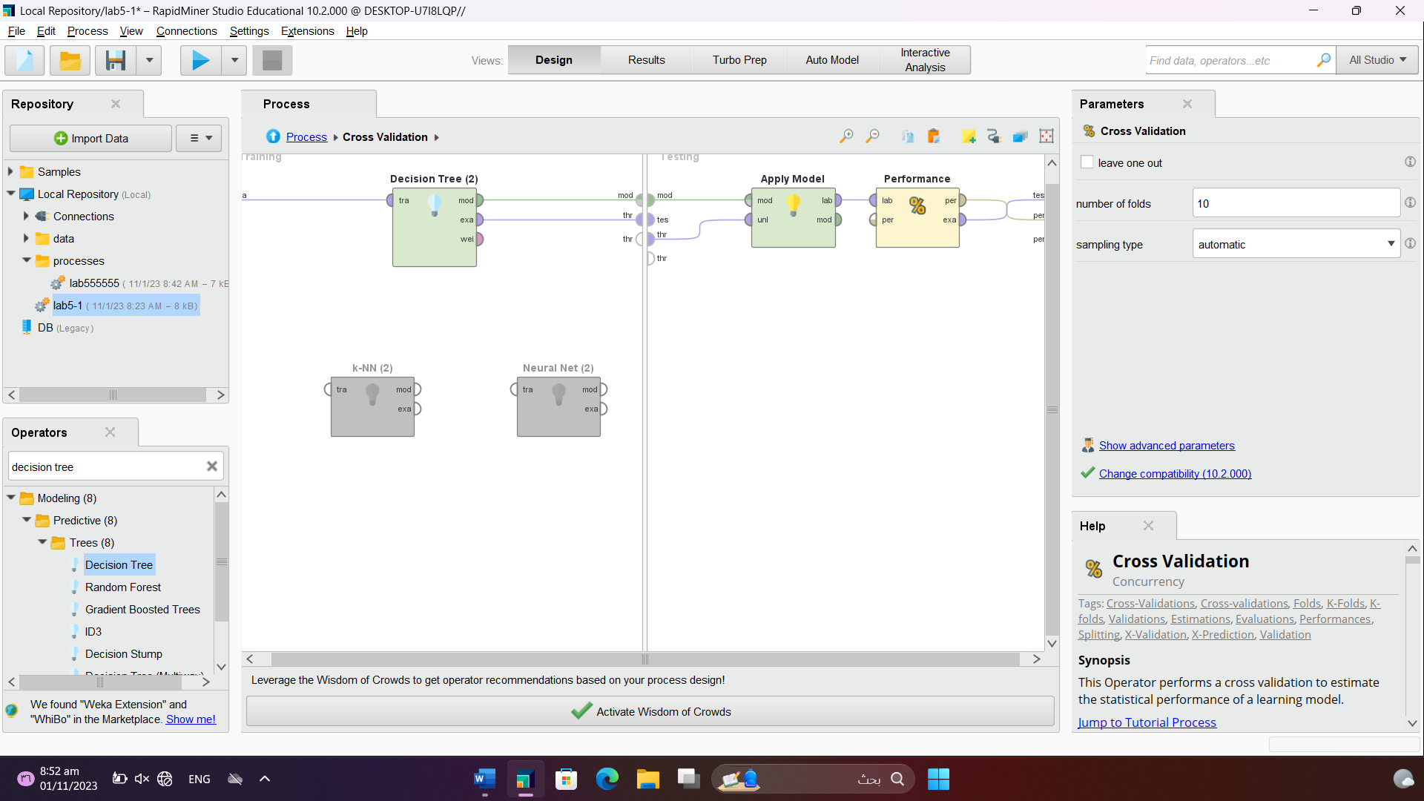

• Show your final model (capture the image

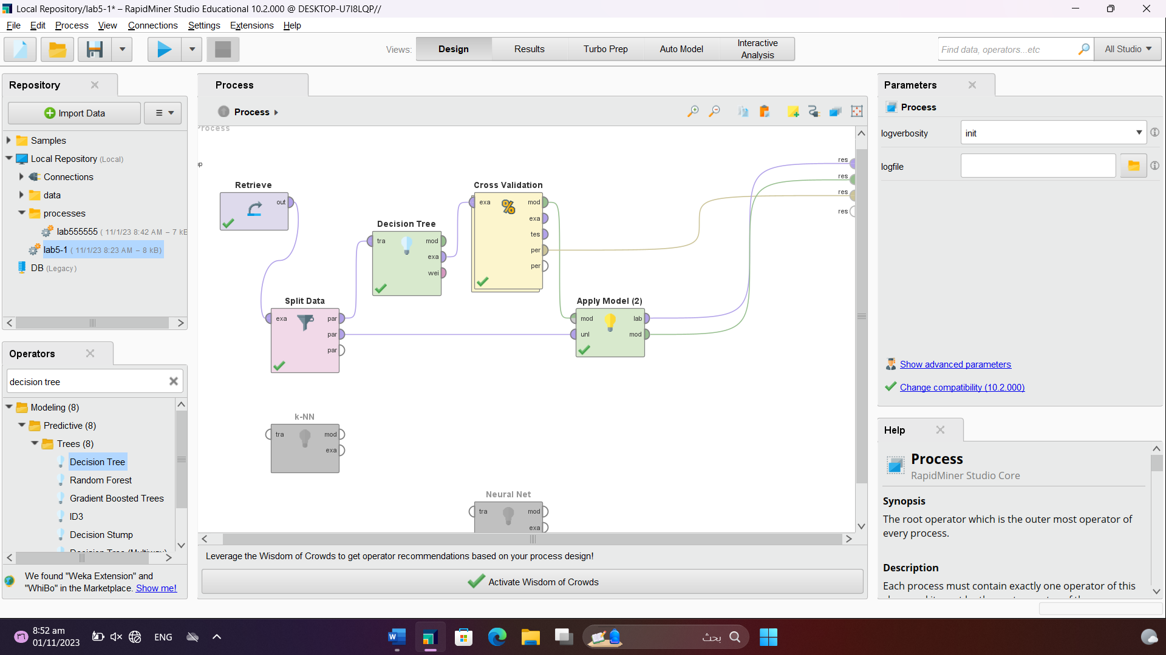

1. Compare the performance percentage of kNN, Neural Net and Decision Tree based on your result above – and specify which model classification model you will use to classify data for future Iris dataset

The KNN algorithm has a prediction accuracy value of 98.52%, The Neural Net 96.67%and the Decision Tree algorithm has prediction accuracy of 97.41% So, I will use the KNN it is one of the simplest classification algorithm . it can give highly competitive results.